The laboratory work 12
This Pandas exercise project will help Python developers to learn and practice pandas. Pandas is an open-source, BSD-licensed Python library. Pandas is a handy and useful data-structure tool for analyzing large and complex data.
Practice DataFrame, Data Selection, Group-By, Series, Sorting, Searching, statistics. Practice Data analysis using Pandas.
In this exercise, we are using Automobile Dataset for data analysis. This Dataset has different characteristics of an auto such as body-style, wheel-base, engine-type, price, mileage, horsepower, etc.

Automobile_data.csv

Exercise 1: From the given dataset print the first and last five rows
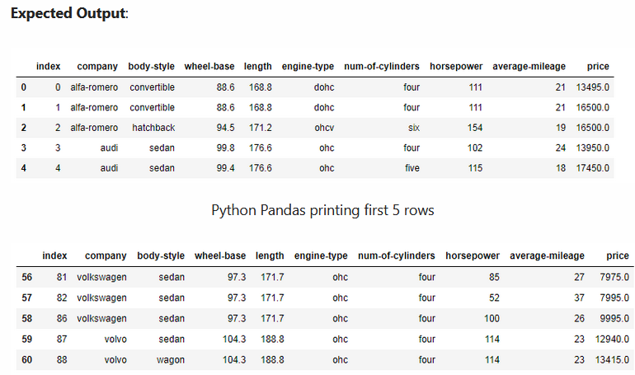

Exercise 2: Find the most expensive car company name

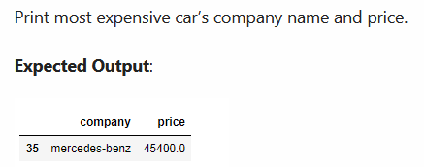

Exercise 3: Print All Toyota Cars details

Expected output

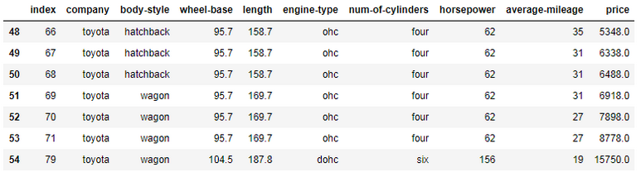

Exercise 4: Count total cars per company

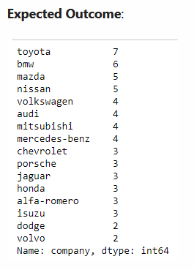

Exercise 5: Find each company’s Higesht price car

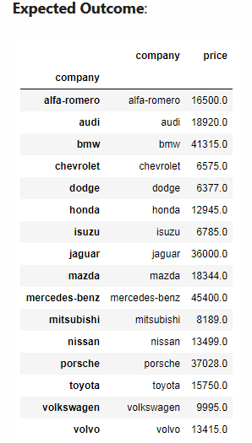

Exercise 6: Find the average mileage of each car making company
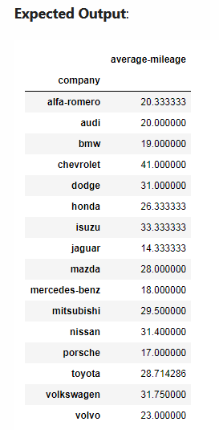

Exercise 7: Sort all cars by Price column
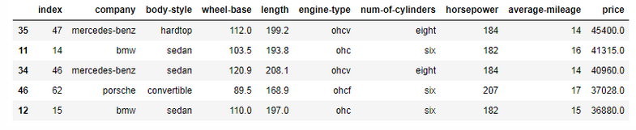

Exercise 8: Concatenate two data frames using the following conditions
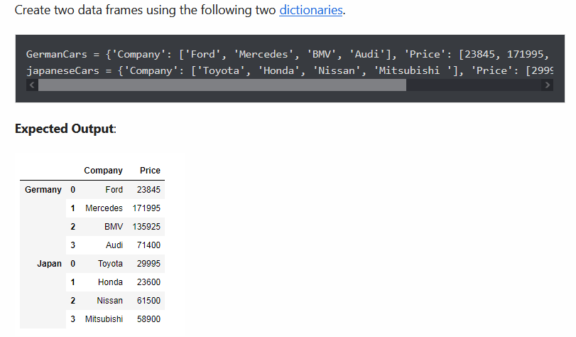

Exercise 9: Merge two data frames using the following condition
